**Week 2 Module 2.2 Assignment**

Juan Macias Vasquez

Bellevue University

CSD310-H323 Database Development and Use (2255-DD)

**Adam Bailey**

June 6th, 2025

Module 1.3 Assignment

Module 2.2 Books ERD

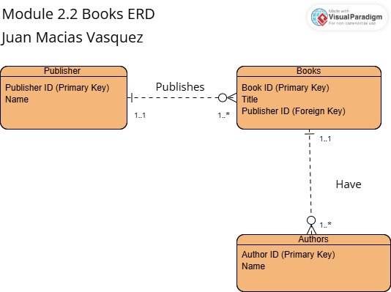

Made in Visual Paradigm

<https://online.visual-paradigm.com/diagrams/features/erd-tool/>